EARLY DEMENTIA DETECTION AND PREDICTION RISK
A DATA SCIENCE PIPELINE FOR DEMENTIA CLASSIFICATION
ICT 583 – DATA SCIENCE APPLICATION
ASSIGNMENT 2
EDNA WANJIKU
35793568

Table of Contents
1. Introduction 3
1.1. Objectives 3
2. Dataset Description 4
3. Data Preprocessing 4
3.1. Encoding 5
3.2. Missing Value Imputation 5
3.3. Detection of Outliers 5
3.4. Feature Removal and Scaling 5
3.5. Train/Test Split 5
4. Exploratory Data Analysis 5
4.1. Univariate Distribution using Histogram 6
4.3. Skewness 9
4.4. Correlation 9
4.5. Target Variable distribution 10
4.6. Numeric Predictor vs Target Variables (For feature Analysis) 10
4.7. Categorical Predictors and Target 11
5. Prediction Modeling 12
5.1. Logistic Model 12
5.2. Support Vector Machine 12
5.3. Random Forest Model 12
5.4. Performance Metrics 12
6. Results for Model and Prediction 12
6.1. ROC Comparison 13
6.2. Best Performing Model 14
7. Further Discussion 14
7.1. Disadvantages and Limitations 14
8. Conclusion 15
References 15

Introduction
Dementia refers to a broad cluster of symptoms with progressive cognitive decline that affects memory, reasoning, language, and emotional control. It mainly affects more than 55 million people, with nearly 10 million people diagnosed each year, which makes it a significant health challenge [1]. Hong Kong, to be specific, carries a significant burden of dementia in the acute stage and the rapidly aging population, thus increasing pressure in the healthcare and social care industry [2].
Early and accurate information about the impairment is crucial, enabling clinical intervention, reducing the burden on caregivers, and thus improving quality of life. The MMSE is one of the widely validated and adopted screening instruments helped in assessing cognitive impairment, detecting dementia [3]
Machine Learning and Data Science methodologies have emerged as modern and powerful complements to the traditional screening, which have enabled the identification of complex and non-linear patterns in health data. Supervised Classification models that include logistic regression, support vector machine, and ensemble tools such as random forest have shown a strong predictive performance.

Objectives
The main objective of the project is to implement a full end-to-end data science pipeline for a real-world application of the health dataset collected in Hong Kong, with the main goal of predicting MMSE_class, which is a binary indicator of the cognitive impairment status. This project aims to:
- Clean, preprocess, and explore the dataset to identify patterns and the relationships between health and the demographic variables
- Training and evaluating two machine learning classification models, Logistic Regression being the baseline model, SVM alongside the Random Forest Model.
- Compare the best performing model using accuracy, AUC, and ROC analysis to determine an effective approach
- Derive key insights from model insights whereby the results could support early dementia screening in community health settings.
- Derive key actionable insights from model results that could support early dementia screening.

Dataset Description
The dataset used was adapted from a mobile health care service delivered with a non-governmental organization managing elderly care centers across various districts of Hong Kong. This was delivered free of charge to elderly residents between 2008 and 2018, capturing a longitudinal, broad cross-section of the population, and each record of the dataset represents one individual case and multiple health demographic and functional variables. The MMSE_class is a binary classification variable, indicating whether a participant showed signs of cognitive impairment.
Variable | Type | Description
Age | Numeric | Age in years
Body_weight | Numeric | Body weight (kg)
Body_height | Numeric | Body height (cm)
Waist | Numeric | Waist Circumference
Education_id | Categorical | Level of education
Mobility | Categorical | Mobility Status
Hyperlipidaemia | Categorical | Presence of Hyperlipidaemia

The below shows the summary characteristics of the numeric variables, showing a dataset of the older adults considered in the variability in physical measurements
Variable | Mean | Median | Standard Deviation | Minimum | Maximum
Age | ~ 81.2 | 82.0 | ~7.4 | 60 | 100+
Body weight | ~ 55.8 | 55.0 | ~10.2 | 28 | 110
Body height | ~ 155.1 | 155.0 | ~ 8.9 | 125 | 185
Waist | ~ 86.7 | ~86.0 | ~11.5 | 55 | 135

Data Preprocessing
This is a major process and key step in any data science pipeline since it affects the data quality and reliability of the modeling outcomes, especially in the accuracy of the outcomes. There were preprocessing steps considered and applied to this dataset, each justified by the nature of the data and the requirements of the selected models.

Encoding
Categorical variables were converted to factors, including Education_ID, Mobility, MMSE_class, and Hyperlipidemia. This ensured correct statistical treatment and prevented the variables from being interpreted as continuous numeric variables. DummyVars() from the caret package was applied to factor all predictors prior to modeling and converted to binary indicators

Missing Value Imputation
Missing values were identified using colSums(is.na) and visualized as a percentage for each column. For the numerical variables, they were imputed using the median a robust approach that is resistant to the influence of the outliers and the skewed distribution. Categorical variables were imputed using the mode of each column; these 2 methods preserve the statistical properties of each variable

Detection of Outliers
Outliers in the numeric variables (Age, body_weight, waist) were detected using the Interquartile Range method. Values falling below Q1- 1.5, IQR or above Q3 + 1.5 IQR were capped to their respective boundary values, reducing the distorting influence of the extreme values on the model parameters without deleting the records from the existing dataset

Feature Removal and Scaling
ID column was removed since it is a unique identifier that has no predictive value. Before model training, features were standardized using z-score scaling(centering and scaling via preProcess() using training set statistics and applied consistently to both the training and test sets. Standardization is important for distance-based and gradient-based algorithms such as SVM and logistic regression.

Train/Test Split
Dataset was portioned into 70% training and 30% testing using the stratified random sampling (createDataPartition()), ensuring that the class distribution of MMSE_class was preserved proportionally across both the splits (seed set to 123).

Exploratory Data Analysis
EDA was conducted to provide insights, analyze the dataset, and identify patterns before applying machine learning models. The following gives the analyses and the visualizations:

Univariate Distribution using Histogram
Histograms were generated for the numeric variables in this case: Age, body_weight, body_height, and waist. Age in this case showed a skewed distribution consistent with the participants' cluster. The body_height in this case shows a balanced distribution; the skewed values can be observed
Figure 1: Histogram for Age, Body_weight, body_height, waist

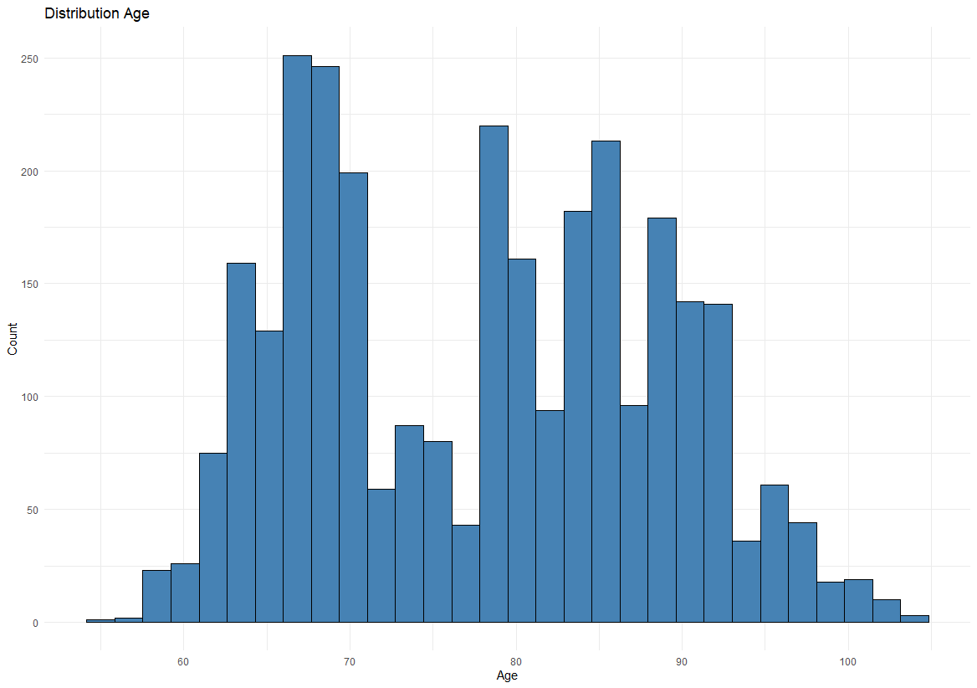

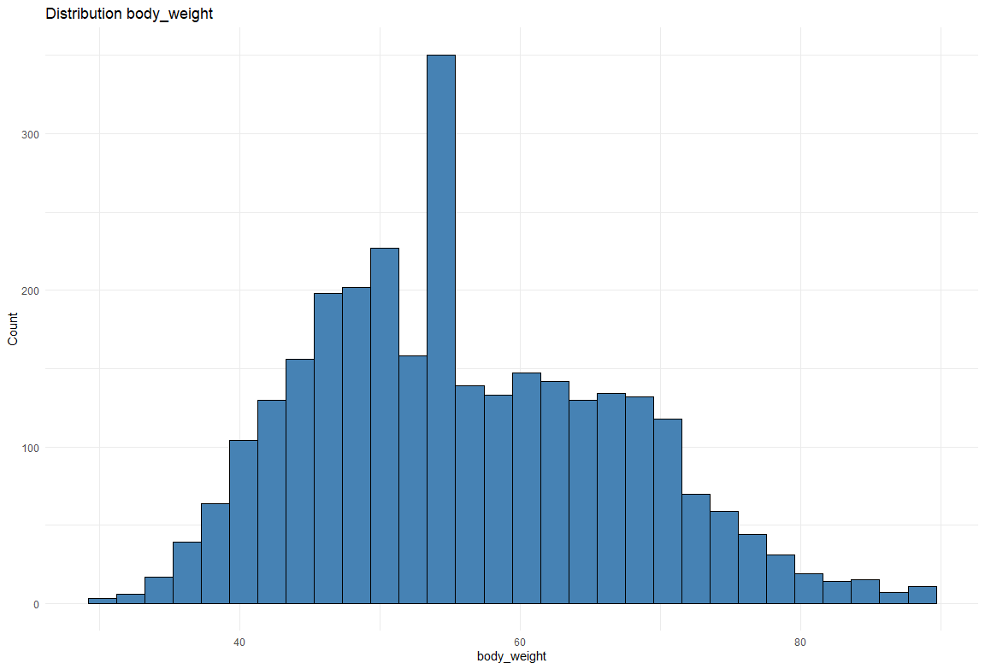
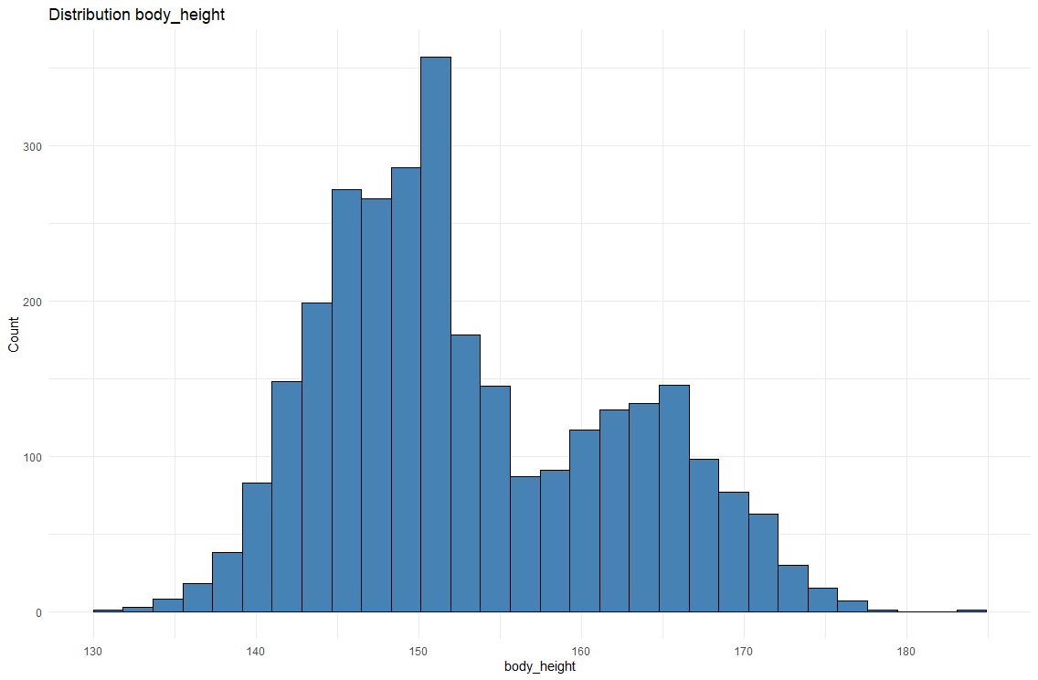
  - Outlier Detection
The boxplots were produced for each numeric variable to confirm the presence of outliers. Body_weight and waist showed the most outliers, and these were addressed through IQR-based capping described in the preprocessing section. The plots below account for the outliers in Age, body_weight, body_height, and waist variables
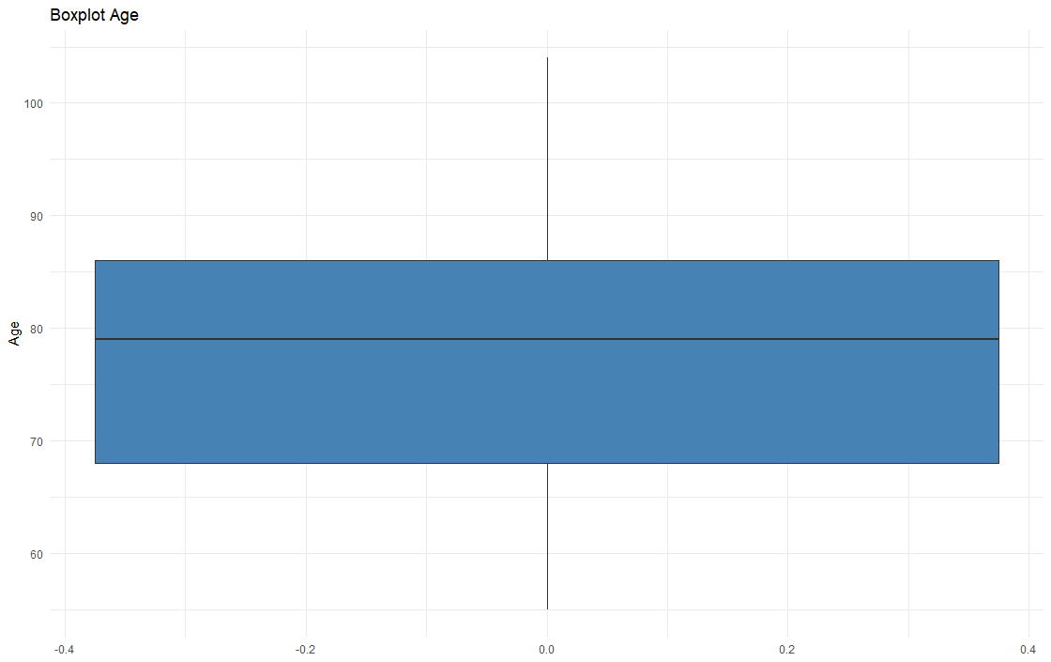
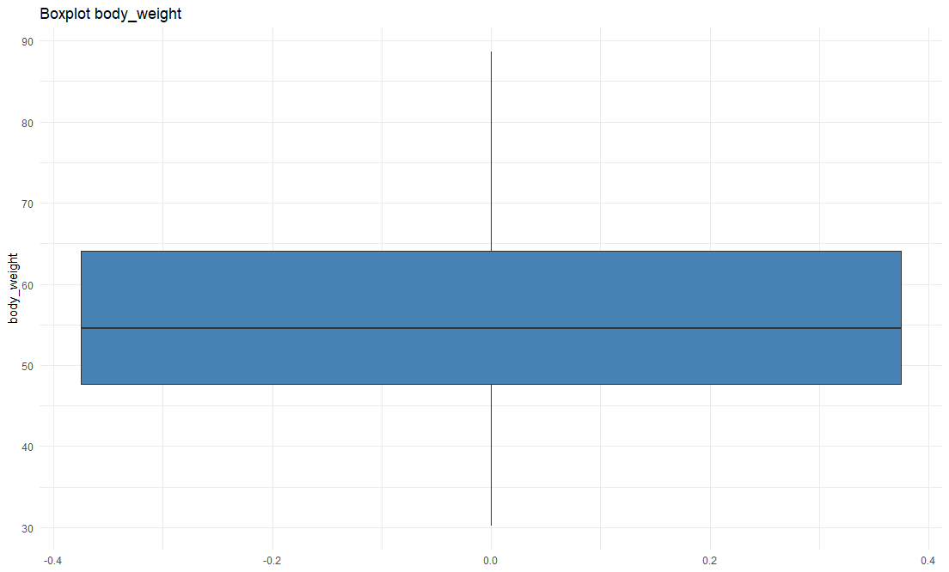
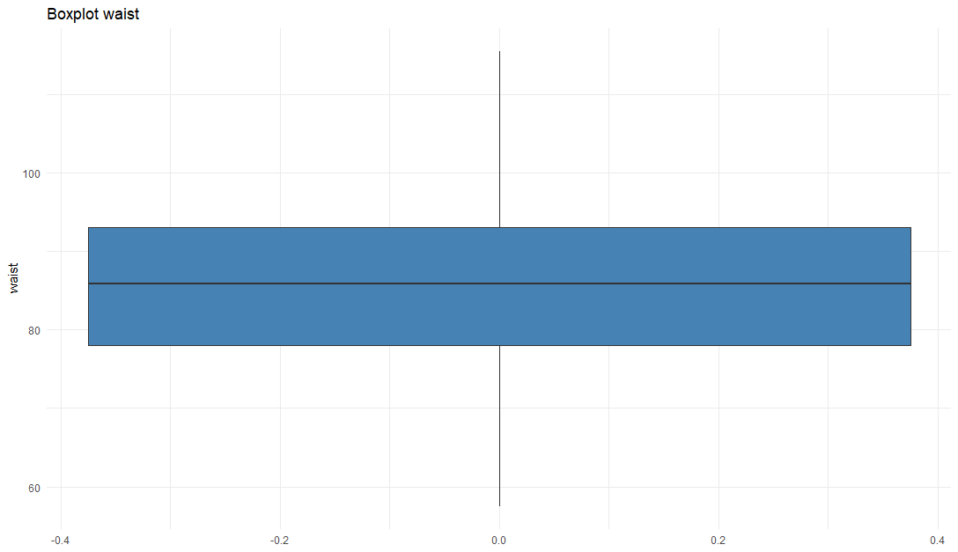

Skewness
The skewness was calculated for the numeric variables. For Age(0.120), body_weight(0.381), body_height(0.457), and waist (-0.0248), which were in an acceptable range between -0.5 and 0.5, showing the variables were normally distributed within the normal skewness, making transformation necessary.

Correlation
The Pearson correlation matrix was done for the numerical variables and plotted using corrplot(). body_weight shows a positive correlation, which is expected. Age shows a weak to moderate correlation with other variables. There’s no perfect collinearity for the predictors (>0.90), indicating that multicollinearity is not a concern for the modeling. The diagram below shows the correlation of the variables
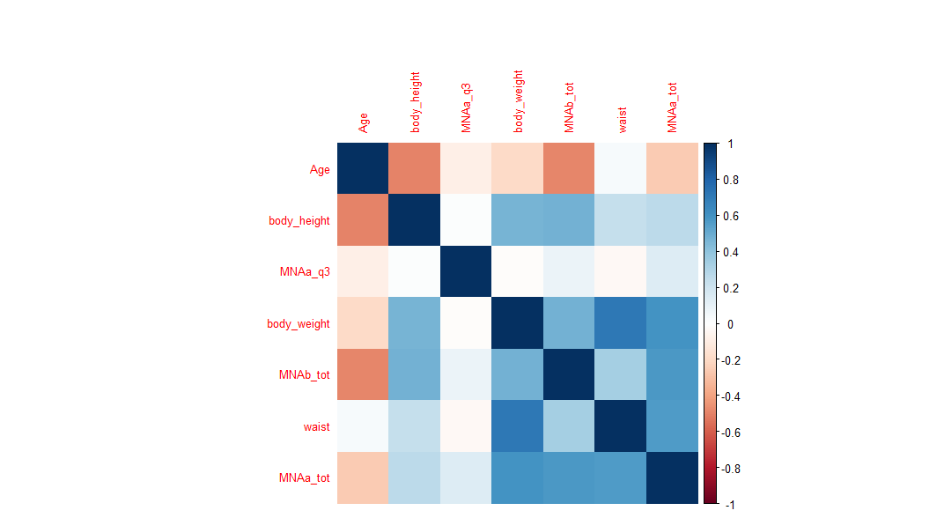

Target Variable distribution

The class distribution of the MMSE_class was determined by using the frequency and the proportion and understanding the class balance is crucial for model selection and evaluation. It’s significant as an imbalance can be biased and the classifiers towards the class, hence making the distribution indicate a moderately imbalanced dataset.

Numeric Predictor vs Target Variables (For feature Analysis)

The boxplots were produced to compare Age and body weight distribution across MMSE class categories. Older and those with lower body_weight have shown higher rates of cognitive impairement suggesting that both age and even physical status can be informative predictors. The visual below shows the feature retention decision
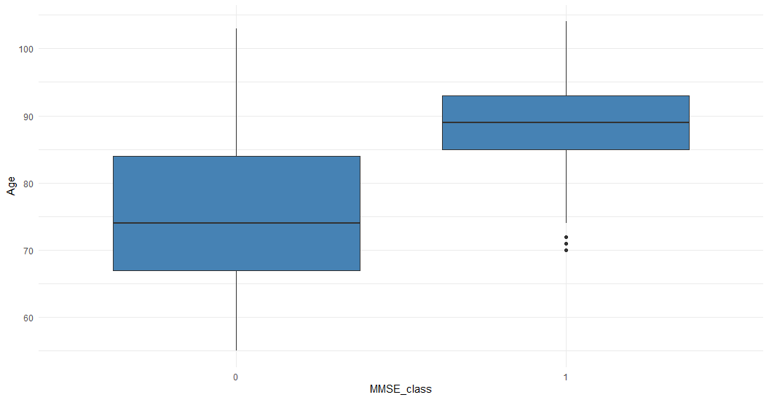

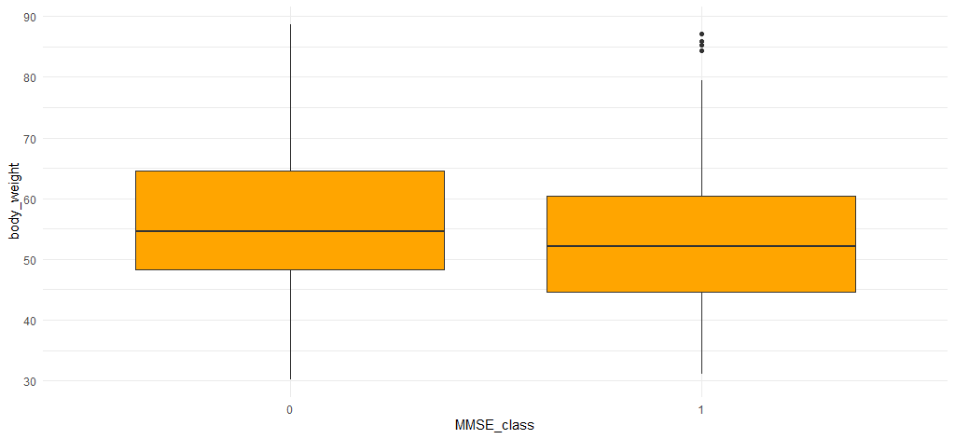

Categorical Predictors and Target
Proportional tables were computed for the categorical variables, for example, Mobility vs MMSE_class. The results in this case showed that participants with limited mobility show a high proportion and cognitive impairment consistent with the evidence of dementia, and the risk

Prediction Modeling
Two key models were selected and evaluated: the logistic model as the baseline model, and the SVM as the advanced model. Random Forest was included for comparative analysis. Scaling was done first, and modeled across 70% training partition and 30% testing for evaluation.

Logistic Model
This is a well-established statistical classification that models the odds of a binary outcome in this case as a linear combination of predictors [4]. This was selected as a baseline model because of its interpretability, efficiency, and its widespread use in medical research as a reference classifier. For this model, regression gives a useful performance, whereby the complexity and the added values of the non-linear models can be determined
The model was trained on the glm () function in R with binomial. The predicted probabilities set a threshold at 0.5 to provide the class predictions

Support Vector Machine
This is a very powerful classifier that mainly seeks to find the optimal hyperplane separating the classes with high-dimensional features [5]. A basis function was used enabling the SVM to capture the non-linear decisions that logistic regression cannot model and with this model, it’s well-suited to a high-dimensional dataset with mixed features even after scaling which makes it appropriate given the dummy encoded variables.
This model was trained using the svm () function from (e1071) package set probability as TRUE and give the ROC analysis. SVM with the RBF kernel requires no distributional data about the features, giving a more flexible model approach. The trade-off is that SVM models are more expensive and less interpretable compared to logistic regression

Random Forest Model
This is an ensemble method that mainly builds multiple decision trees in training and aggregates their outputs via majority rule [6]. As it is robust to overfitting, it handles mixed data types effectively and would require minimal hyperparameter tuning for the competitive baseline results. (ntree = 100) was used. Random Forest model gives more variable importance scores, giving an interpretability advantage.

Performance Metrics
Evaluation was done using the confusion matrix, accuracy, and the ROC curve, which is normally associated with the AUC metric. AUC is important as it normally gives detailed information regarding the imbalance and measures the model’s ability to differentiate the classes across the classification thresholds [7]

Results for Model and Prediction
The model's results below are summarized based on the evaluation and the test set:
Model | Accuracy | AUC | Commentary
Logistic regression (baseline model) | 89.54% | 0.9366 | As a baseline model, it’s considered a strong linear discriminator
Support Vector Machine | 89.32% | 0.8330 | As non-linear, the AUC is slightly lower than the baseline model but shows a good performance
Random Forest Model | 89.66% | 0.9385 | This shows a much better accuracy, hence a more considerable top-performing model, set even for a high AUC and accuracy

The three models have almost similar accuracy, 89.3 – 89.7%, showing a high classification performance. For the AUC values, however, the values revealed show a difference in the ability, the logistic regression gave an AUC of 0.937, and for random forest as 0.939, and outdid SVM (AUC = 0.833).

ROC Comparison
The ROC curves plotted below are for the three models highlighted. Random Forest curve represented as green, Logistic Regression as blue, and Support Vector Machine Model as red. SVM’s lower AUC suggests that while as considered accurate, it’s less reliable across the probability range
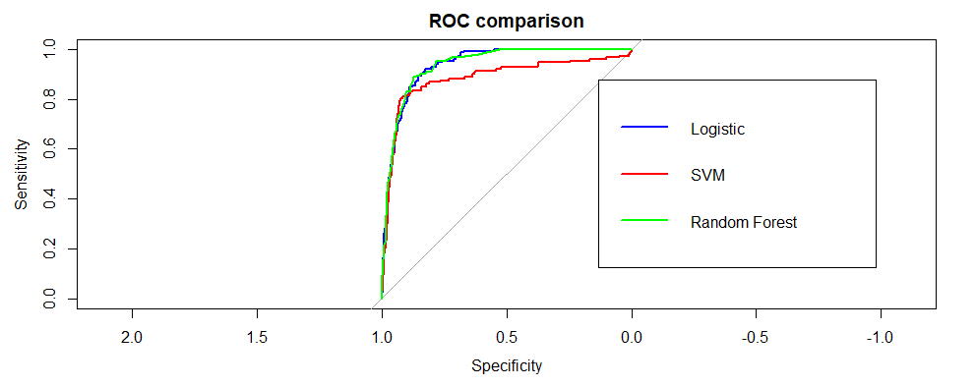

Best Performing Model
The best performing model with the highest accuracy is the Random Forest(89.66%) with the highest AUC (0.9385), which makes it the best performing model in the study. Its structure aggregates the predictions from the independent decision trees, allowing it to get the complex, non-linear feature interaction that neither SVM nor even the logistic regression model achieves. The Random Forest model, as well is resistant to overfitting through the bootstrap aggregation method and random feature at each split
However, the margin improvement for the Logistic Regression is very narrow(based on the AUC with a small marginal difference, which is a key finding, and the baseline models simply explain this variance in the given outcomes. This suggests the predictors of this dataset that can have a larger difference structure. The additional complexity of the Random Forest gives only the marginal gains

Further Discussion
The results of the project may have different implications. Firstly, all three models have a high accuracy (range of 89%), proving that the predictors carry a meaningful signal for predicting cognitive impairment, measured by the MMSE. This fully aligns with the fact that the clinical evidence identifies age, functionality, mobility, and education level as risk factors for dementia. [2] [3].
Logistic Regression models’ strong performance as a baseline model highlights a key consideration for usage in low-resource healthcare settings, for example, Non-Governmental Organizations for elderly care, and for such an interpretable model, it may be preferable to use.
SVM’s lower AUC(0.833) mainly reflects the sensitivity to the kernel choice hyperparameters tuning for grid search, SVM performance, which could potentially improve and even be more competitive with other models
Given in a public health perspective, a screening model could enable health care community workers to flag elderly individuals who are at risk for cognitive decline, facilitating earlier clinical and intervention [1]

Disadvantages and Limitations
There were several limitations to the findings, which are listed below:
- The dataset from 2008-2018 may have changed in terms of the health patterns, the population demographics, and even the clinical practices, which may have changed, limiting the generalization of it
- Missing data imputation methods, such as mode and median, are a simple strategy and may not fully reflect the true distribution of the values. If other imputation methods are given or used, they could provide robust estimates
- The models SVM and Random Forest were trained with default hyperparameters- meaning there was a limit in the optimization. A much more systematic cross-validation was not performed in the scope of this project
- Class imbalance, which happens, and if present, could present bias towards the majority class, and to address this, SMOTE could be used to resolve this

Conclusion
This project implemented a comprehensive data science pipeline combining data loading, pre-processing, exploratory data analysis, feature engineering, classification modeling, and evaluation on the real-world dataset from Hong Kong with one major objective: to predict cognitive impairment using the MMSE classification.
The analysis showed that demographic and psychological health can dependably predict MMSE-based cognitive impairment with 89% accuracy. Given the three models as evaluated, Random Forest achieves the highest performance (Accuracy 89.66%, AUC 0.939), followed closely by Logistic Regression( Accuracy 89.54%, AUC 0.937). SVM performs slightly worse than both models, suggesting that a better scope could show improvement through hyperparameter optimization.
This project encompasses the value of the data-driven approach in assisting the cognitive health screening for the elderly population, especially in resource-limited settings.
Given the future works, other deep learning models, and integration of using biomarkers can be implemented to provide comprehensive and improve predictive accuracy.

References

[1] | W. H. Organization, 31 March 2025. [Online]. Available: https://www.who.int/news-room/fact-sheets/detail/dementia.
[2] | L. Lam, S. S. M. Chan and S. Wong, "Prevalence of very mild and mild dementia," Prevalence of very mild and mild dementia in community-dwelling older Chinese people in Hong Kong, September 2007.
[3] | M. Folstein and P. McHugh, "Journal of Psychiatric Research," A practical method for grading the cognitive state of patients for the clinician, 1975.
[4] | D. Hosmer and S. Lemeshow, "Applied Logistic Regression," 2013.
[5] | C. Cortes , "Support-Vector Networks".
[6] | T. Friedman and T. Hastie, "Statistics in Society," The Elements of Statistical Learning: Data Mining, Inference, and Prediction, 2010.
[7] | J. A. Hanley and B. McNeil, The meaning and use of the area under a receiver operating characteristic (ROC) curve.

Please tick (✔) all that apply to your use of AI tools (e.g., ChatGPT, Copilot, Gemini) in this assignment:
Written Report and Documentation:
✔I did not use any generative AI tools in preparing this assignment.
✔ I used AI to check spelling, grammar, or sentence clarity only.
✔ I used AI to brainstorm or organise the structure of the report.
✔ I used AI to refine or reword my writing, while ensuring the ideas remain my own.
✔ I used AI in other ways (please specify):
___________________________________________
Coding and Technical Work:
✔ I did not use any generative AI tools for code, modeling, or analysis.
✔ I used AI tools (e.g., GitHub Copilot, ChatGPT) to help write or complete code snippets (e.g., functions, visualizations).
✔ I used AI to debug or explain existing code.
✔ I used AI in other ways (please specify):
___________________________________________
✔ I confirm that I I can explain all code, analysis, and results in my submission, and that this work reflects my own understanding, learning and academic integrity

